THIS IS JAPANESE KNOTWEED (BAMBOO), AN
INVASIVE SPECIES
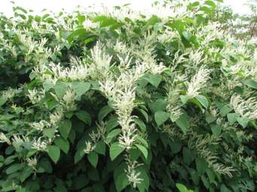
DO NOT BRING IT TO TRANSFER STATION
BECAUSE THAT WILL CONTRIBUTE TO ITS SPREAD
THE TOWN OF COLTON HAS A KNOTWEED CONTROL PROGRAM. IF YOU HAVE A PROBLEM WITH THIS PLANT, CONTACT
ANDREA MALIK AT 262-2034, BTIDIRECTOR@TOWNOFCOLTON.COM
TREATMENT FOR THIS INVASIVE IS DONE IN THE LATE SUMMER/FALL, AFTER THE PLANT FLOWERS

